As the last date for Operational Research draft submission is approaching near we wish to remind you to kindly submit your Operational Research proposal on or before 15th October in soft copy by mail to unicef.or@gmail.com.
We also wish to inform you that Dr (Prof.) Deoki Nandan Foundation has announced a cash award of Rs. 5100 for the best original research article in oral presentation during the conference.

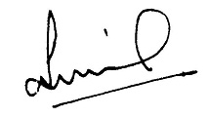

(Organizing Secretary)

